@author: 荒野无灯@80x86.io

@date: 2017-07-06

git blame 加持，法力无边。

git blame 加持，法力无边。

git blame 加持，法力无边。





情况是这样的，某个文件中的某一行代码，昨天还工作好好的，今天同事给我一个截图：

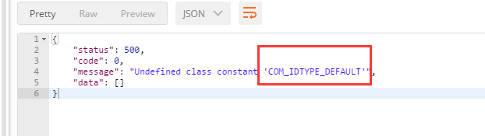

COM_IDTYPE_DEFAULT 之前明明有定义，那么肯定是某个人把它给删除了。so , let's find him.

尝试一，用git log

git log -S<string> does the job, but if you need to make more complex searches you can use git log -G<regex>.

From the man:

-G<regex>

Look for differences whose patch text contains added/removed lines that match <regex>.

尝试用：

git log -- common/models/Company.php

 git log --oneline -S'COM_IDTYPE_DEFAULT' common/models/Company.php

都是不行的。

git log doesn't shows a diff for merge commits by default. The -c or --cc flags should do the trick:

git log -c -S'missingtext' /path/to/file

More discussion/explanation [here](http://git.661346.n2.nabble.com/log-p-hides-changes-in-merge-commit-td5896280.html" \t "http://301780f0.wiz03.com/share/s/_blank).

git blame 大法好

Great answer to this on Super User: [https://superuser.com/questions/541681/git-how-do-i-find-which-commit-deleted-a-line](https://superuser.com/questions/541681/git-how-do-i-find-which-commit-deleted-a-line" \t "http://301780f0.wiz03.com/share/s/_blank)

Use git blame with the --reverse option:

$ git blame --reverse START.. file.ext

where START is a revision which still contains the line in question.

出现问题的分支是 test 分支。

用 jetbrains phpstorm 查看 Company.php的修改记录发现在如下图所示的提交之后，这一行就奇怪地消失了。通过右击show diff 也看不到是图中哪个提交干掉了。

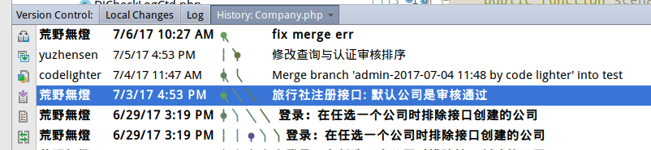

因为删除掉这一行的不是一个正常的commit, 而是一个merge commit. 说明有人在merge代码的时候把这一行给干掉了。

phpstorm里选择 copy revision number , 复制得到rev id:  705648f43ea80a8efc7c4966f5273f5f4bc3dab3

根据上面搜索到的blame用法，我们用命令：

1. git blame --reverse 705648f43ea80a8efc7c4966f5273f5f4bc3dab3.. common/models/Company.php

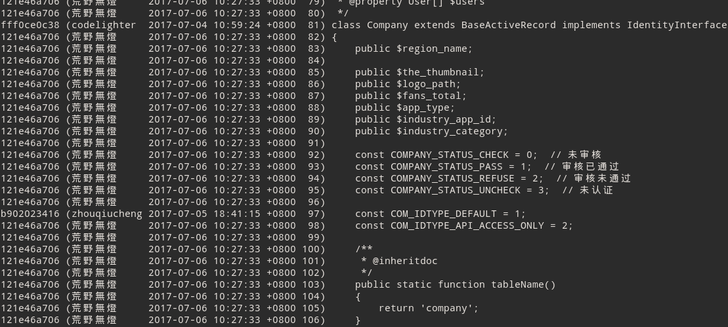

从这一条我们发现，一直到 b902023416 ，这一行还是存在的：

1. b902023416 (zhouqiucheng 2017-07-05 18:41:15 +0800 97) const COM_IDTYPE_DEFAULT = 1;

所以，可以确定，这一行是在 b902023416 这个提交之后被干掉的。

加上-L显示更友好：

1. git blame --reverse -L90,+20 705648f43ea80a8efc7c4966f5273f5f4bc3dab3.. common/models/Company.php

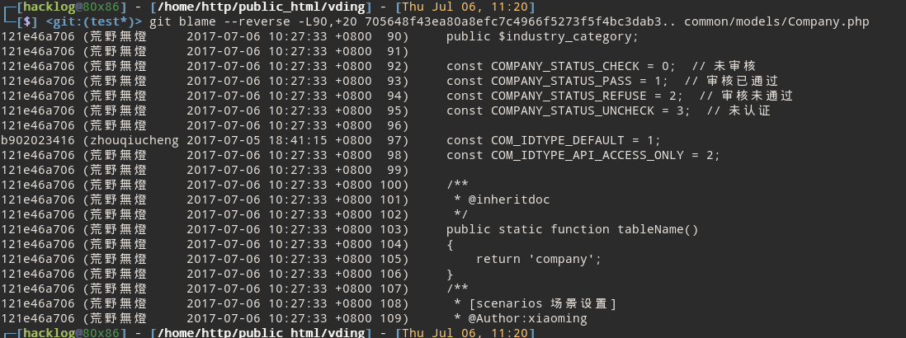

然后， 到底是谁干掉了这一行呢？ 我们继续用 jetbrains phpstorm查看git log:

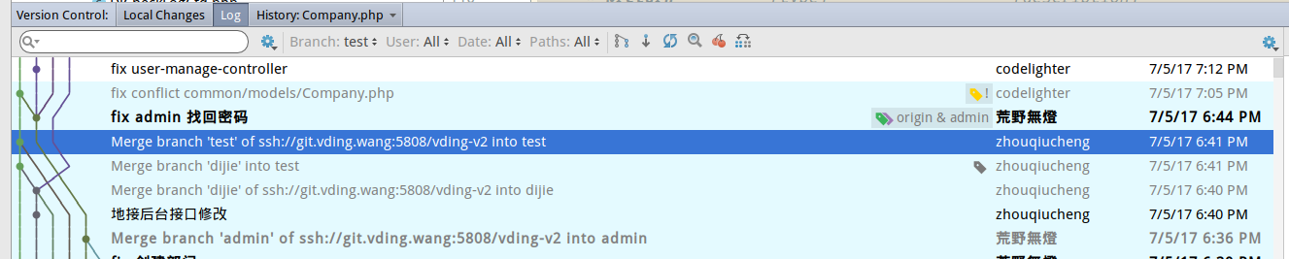

如上图， b902023416 就是高亮的那一行。

再往上走，又有一个merge： ab7dbdf38228eb079807a1fc0a728bd3b0bd03b8 (**fix conflict common/models/Company.php**)

1. ┌─[hacklog@80x86] - [/home/http/public_html/vding] - [Thu Jul 06, 11:55]
2. └─[$] <git:(test*)> git show ab7dbdf38228eb079807a1fc0a728bd3b0bd03b8
3. commit ab7dbdf38228eb079807a1fc0a728bd3b0bd03b8
4. Merge: b90202341 f65fcb9b7
5. Author: codelighter <shb8845369@gmail.com>
6. Date: Wed Jul 5 19:05:28 2017 +0800
7. fix conflict common/models/Company.php

这个merge 的两个父节点分别是：

b902023416e6a8ba5190b15d81f00dd02595aff9

f65fcb9b78a644402c970a66d0cbd2f155d4841f

b90202341 就是我们刚才git blame出来的，显示是已经有那一行了. 所以不需要再怀疑。

git checkout f65fcb9b7

发现common/models/Company.php 没有那一行.

所以，罪魁祸首就是 ab7dbdf38228eb079807a1fc0a728bd3b0bd03b8

这个merge 把  f65fcb9b7 (admin分支) 合并到   b90202341 (test分支)， 然后在合并的时候，

common/models/Company.php 文件产生了冲突。对于common model下的Company.php， 实际上 test 分支的代码是比admin的要新的。

因此，合并者在解决冲突时，错误的选取了 admin分支的部分，导致  COM_IDTYPE_DEFAULT 这个常量定义这一行代码丢失。

**git blame --reverse** can get you close to where the line is deleted. But it actually doesn't point to the revision where the line is deleted. It points to the last revision where the line was **present**. Then if the **following revision** is a plain commit, you are lucky and you got the deleting revision. OTOH, if the following revision is a merge commit, then things can get a little wild. As part of the effort to create **difflame** I tackled this very problem so if you already have python installed on your box and you are willing to give it a try, then don't wait any longer and let me know how it goes.

[https://github.com/eantoranz/difflame](https://github.com/eantoranz/difflame" \t "http://301780f0.wiz03.com/share/s/_blank)

其它技巧：查看指定范围行的修改

[Since Git 1.8.4](https://github.com/git/git/blob/v1.8.4/Documentation/RelNotes/1.8.4.txt" \l "L210" \t "http://301780f0.wiz03.com/share/s/_blank), git log has [-L](https://github.com/git/git/blob/v1.8.4/Documentation/RelNotes/1.8.4.txt" \l "L210" \t "http://301780f0.wiz03.com/share/s/_blank) to view the evolution of a range of lines.

To see commits affecting line 40 of file foo:

git blame -L 40,+1 foo

The +1 means exactly one line. To see changes for lines 40-60, it's:

git blame -L 40,+21 foo

OR

git blame -L 40,60 foo

The second number can be an offset designated with a '+', or a line number. [git blame docs](https://git-scm.com/docs/git-blame" \t "http://301780f0.wiz03.com/share/s/_blank)